Remove Glare from Images

*Bachelor thesis*

*by*

**Aman Prabhakar**

**Anuj Kumar**

**Gautam Raj**

Under the supervision of

**Dr Oishila Bandhyopadhyay**



A thesis submitted to

**Indian Institute of Information Technology, Kalyani**

*for the partial fulfillment of the degree of*

**Bachelor of Technology**

**in**

**Department of Computer Science & Technology**

**Autumn Semester – 2022**

**Abstract**

**Contents**

**1 Introduction 1**

**2 Present Methods**

**3 Work Done**

**4**

**5 Future Scopes**

**Chapter 1**

**Introduction**

* 1. **Background**

Glare is characterized as a physical defect of lens. The reflective surfaces of lens cause the light to bounce back and forth between its lens elements. The presence of haze significantly degrades the quality of an image captured at night. Similar to daytime haze, the appearance of night time haze is due to tiny particles floating in the air that adversely scatters the line of sight of lights rays entering the imaging sensor. In particular, light rays are scattered-out to directions other than the line of sight, while other light rays are scattered-in to the line of sight. The scattering-out process causes the scene reflection to be attenuated. The scattering-in process creates the appearance of a particles-veil (also known as air light) that washes out the visibility of the scene. These combined scattering effects adversely affect scene visibility that in turns negatively impacts subsequent processing for computer vision applications.

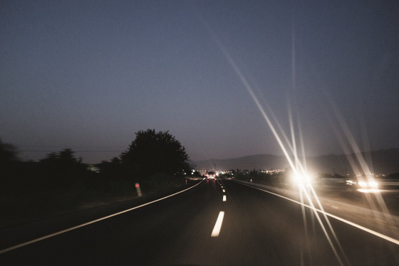

Figure 1. An image showing glare during night time

* 1. **Problems caused due to glare**

**Chapter 2**

**Present Methods**

**2.1 Concept**

Glare in images can be detected using thresholding the image to highlight the bright regions. Current methods further use masking to differentiate between the actual glare and other regions which have relatively higher brightness as compared to the rest of the image. To remove the detected glare, we can use methods like erosion and pixel manipulation.

**2.2 Image segmentation**

Image segmentation is a method of dividing a digital image into subgroups called image segments, reducing the complexity of the image and enabling further processing or analysis of each image segment. Segmentation is the assignment of labels to pixels to identify objects, people, or other important elements in the image.

**2.3 Thresholding**

Image thresholding is a simple, yet effective, way of partitioning an image into a foreground and background. This image analysis technique is a type of image segmentation that isolates objects by converting grayscale images into binary images.

Thresholding uses a value, known as the threshold value, *T*, and compares the intensity of each pixel to this threshold value. Thresholding replaces each pixel in an image with a black pixel if the image intensity is less than the threshold value or a white pixel if the pixel intensity is greater than that threshold.

**2.4 Masking**

The concept of a mask is also known as spatial filtering. Mask is a type of filter which performs operation directly on the image. The filter mask is also known as convolution mask.

To apply a mask on an image, filter mask is moved point to point on the image. In the original image, at each point (x, y), filter is calculated by using a predefined relationship.

**2.5 Gamma Correction**

Gamma correction or gamma is a nonlinear operation used to encode and decode luminance or tristimulus system in video or image systems. Gamma correction is, in the simplest cases, defined by the following power-law expression:

Vout = AVin **γ**

where the non-negative real input value Vin is raised to the power**γ** and multiplied by the constant A to get the output value Vout. In the common case of A = 1, inputs and outputs are typically in the range 0–1.

**2.6 Erosion**

Erosion shrinkens the image pixels i.e., it is used for shrinking of element A by using element B. Erosion removes pixels on object boundaries.: The value of the output pixel is the minimum value of all the pixels in the neighbourhood. A pixel is set to 0 if any of the neighbouring pixels have the value 0.

Chapter 3

Work Done